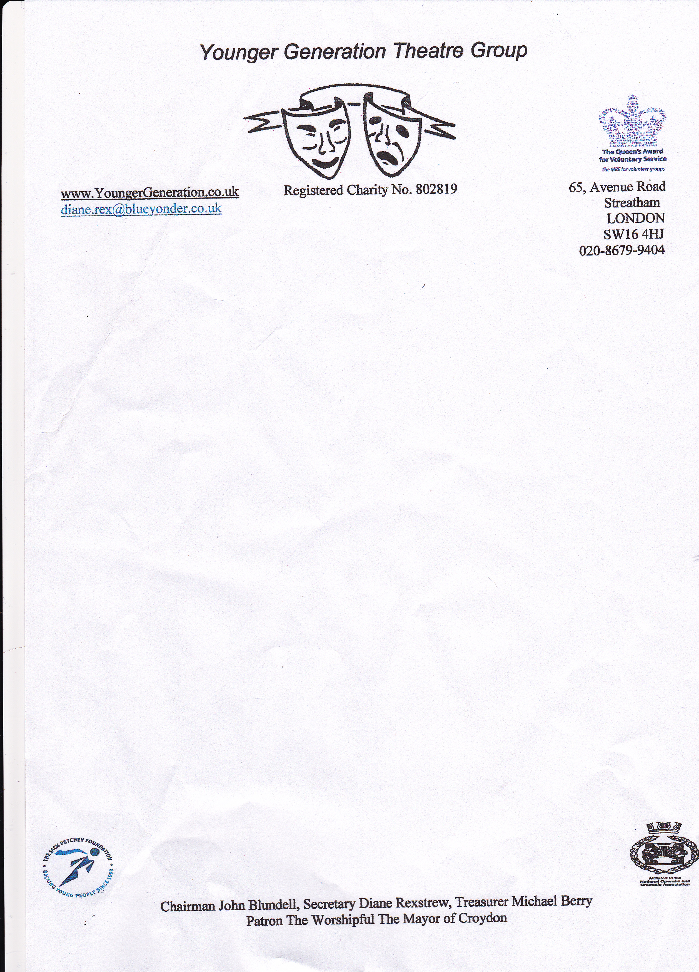

D.G.Rexstrew

65, Avenue Road,
Streatham,
London
SW16 4HJ
020-8679-9404

ygcontactus@gmail.com
Registered Charity No. 802819

www.youngergeneration.uk
January 2025
YG 2025
“Lights, Camera, Action”
Saturday 2nd August 2025

We hope that you enjoyed being part of the YG Cast in 2024 and we would like to invite you back to take part in the 2025 show

This year’s show is called “Lights, Camera, Action” and as the name suggest it is all about films.

Our auditions are going to be on Sunday 9th March at 2.30 at St Marks Church Hall. We ask you all to attend just to see how you have changed and what you now can do since last year. You will not be auditioning as you are already part of the YG Group.

Last year was hard for us as we were trying to get the group up and running again after having to cancel our shows for the last few years due to Covid.

We now need to build on the cast from last year to get more people to join us for 2025. So please see if you can encourage any of your friends or family to join us. For all new people that want to join please can you ask them to fill in the audition form Join YG: Application Form

Last year YG was free to anyone that wanted to join and we waivered our subscription fees and costume deposits that we have always charged in previous years. We are pleased to tell you that we will be doing the same for 2025, but we are asking you all to sell as many show tickets as you can to help pay the cost for us putting on the show as this is the only income we have. You could of course if you would like to help YG by donating an amount towards the group from the Paypal link here Support Our Cause: Donate via PayPal – as we have registered with PayPal as a charity 100% of what you donate comes to us.

Historically we have covered all our costs but last year we made a loss of about £2500. A lot of this money went on hiring St Marks Hall for rehearsals, hire of the Cryer Arts Centre & publicity. We also have our ongoing costs that we have to pay out every year (including the years when we did not have any shows). This includes having to pay for insurance, our Web Page, NODA fees and the rent for our sheds that we have at St Marks. In fact I have just received an invoice for £650 for the shed rent. I also received an invoice for the rent for St Marks for this year’s hire for £1086.

ATTENDANCE AT REHEARSALS

WE MUST STRESS THAT FOR 2025, A MAXIMUM OF THREE WEEKS IS ALLOWED OFF FOR HOLIDAYS OR OTHER COMMITMENTS. If you have any queries about time off, please contact us now.

The show is on Saturday 2nd August with an afternoon rehearsal on, Friday 1st, at CryerArts Centre

The first rehearsal will be on Sunday 27th April, this will be in Scout Hut at the back of St Marks Hall and will start at 3.15.

Further rehearsals in the main hall will all start at 2.30

Please let us know of any Sundays that you will be absent from rehearsals as soon as possible. If you are ill on the day of a rehearsal, please inform us straight away. If you do not arrive (and you have NOT advised us of your absence) we will contact you immediately to ensure nothing has happened to delay your arrival. DO NOT ask any other cast member to tell us if you are not coming, it is up to you to tell us yourself.

Cast members are not permitted to leave St. Mark’s site on their own whilst in our care or go off site to smoke/ Vape (whatever your age). If a cast member goes home without signing out with a Committee Member, their parents will be contacted as to their whereabouts This is not only for cast members’ protection but ours as well as we are responsible for you while in our care..

We do need to know if you want to return this year, so please submit the form - Existing Cast Sign Up Form

Thank You
Look forward to hearing from you soon

Diane (Producer) on behalf of the YG Committee

